Iterative Socket Server
A Study of Iterative Server Performance Under Concurrent Client Load

Matthew Bosworth
Ty Newman

CNT4504 – Computer Networks & Distributed Processing
Professor John Scott Kelly

Introduction

The purpose of this project was to design, implement, and evaluate an iterative socket server and a multi-threaded client capable of generating concurrent requests against that server. An iterative server processes one client connection at a time: it accepts a connection, performs the requested work, returns a response, closes the connection, and only then returns to listening for the next client. By pairing this server with a client that can spawn many simultaneous connection attempts, we were able to directly observe how a strictly serial request-handling model behaves as the number of competing clients grows.

The primary goals of this project were threefold. First to gain hands-on experience building client-server applications in Java using the ServerSocket and Socket classes, including the protocol-level details of sending requests, formatting responses, and detecting the end of a message stream. Second, to practice having a Java program execute operating system commands, such as date, uptime, free, netstat, users, and ps, and capture their output for transmission back to a client. Third, and most importantly for the analytical portion of the assignment, to collect empirical turn-around time data across a range of client loads (1, 5, 10, 15, 20, and 25 simultaneous clients) for each of six supported operations, and to use that data to understand the performance characteristics and limitations of an iterative server architecture.
The remainder of this report is organized as follows. The Client-Server Setup and Configuration section describes the design of both the server and client programs, the design decisions we made, and how they interact. The Testing and Data Collection section explains our testing methodology and presents the turn-around time data we collected for each of the six operations, along with charts illustrating the trends. The Data Analysis section interprets the data and answers the assignment’s questions regarding how increasing client load affects individual and average turn-around times, what we learned about iterative server architectures, and the Lessons Learned section reflects on the challenges we encountered while completing this project.

Client-Server Setup and Configuration
Server Design
The server program, IterativeServer.java, is built around a single java.net.ServerSocket bound to port 4998, a port within the range permitted on the course servers. The server enters an infinite loop in which it calls accept() exactly one per iteration. Because accept() is a blocking call, the server does nothing but wait until a client connects. Once a connection is accepted, the server reads a single line of text from the client. Once a connection is accepted, the server reads a single line of text from the client, which represents a numeric request code from 1 through 6. A Java switch expression maps that code to the corresponding shell command: date for Date and Time, uptime for Uptime, free -h for Memory Use, netstat -tuln for Netstat, who for Current Users, and ps aux for Running Processes.
To actually run these commands, the server uses a helper method, runCommand(), which wraps the requested command in a ProcessBuilder configured to invoke bash -c, redirects the process’s error stream into its standard output stream, and reads every line of output into a StringBuilder using a BufferedReader. The combined output is trimmed and returned as a single String. After the command has produced its output, the server writes that String back to the client over a PrintWriter, followed by a sentinel line containing the literal text “##END##”. This sentinel is essential because command output, such as the result of ps aux, can span many lines, and the client needs an unambiguous signal that the server has finished sending data for this request.

Once the response has been sent, the server closes the client socket in a finally block, prints a short status message to its own console, and loops back to accept(). Because there is no threading anywhere in this loop, only one client connection can be in progress at any given moment – this is precisely the “iterative” behavior the assignment asks us to study. The operating system’s TCP stack will queue additional incoming connection attempts (the ServerSocket’s backlog), but those connections sit idle, fully established at the TCP level but unserved at the application level, until the server finishes the client currently being processed and calls accept() again.

Client Design
The client program, MultiThreadedClient.java, was designed to let us drive controlled, repeatable load against the server. On startup, the client prompts the user for the server’s IP address and port, the operation to request (1 through 6), and the number of client sessions to spawn (1, 5, 10, 15, 20, 25). Each individual client session is represented by an inner class, ClientTask, which implements Runnable. When the user specifies N sessions, the main method creates N separate Thread objects, each wrapping its own ClientTask, and starts all of them in a tight loop with no delay between starts. This causes all N client connection attempts to be issued to the server in rapid succession, simulating N users hitting the server at essentially the same moment.

Each ClientTask records its own start time immediately before opening a new Socket to the server, sends the selected operation code as a single line of text, and then reads lines of response from the server until it encounters the “##END##” sentinel. As soon as the sentinel is read, the task records the elapsed time – this is the turn-around time for that individual client, covering the full round trip of connecting, sending the request, the server performing the work, and the response being received back. Each task adds its elapsed time to a shared AtomicLong (so that concurrent updates from multiple threads are added safely without race conditions) and signals a CountDownLatch to indicate it has finished. The main thread blocks on latch.await() until every spawned client has completed, after which it computes and prints the total turn-around time (the sum of every client’s individual time) and the average turn-around time (the total divided by the number of clients).
Operation
To run a trial, the server program is started first on one of the course servers and left running so it can continually accept connections. The client program is then run, either on the same machine or a different course server, and connects to the server’s IP address on port 4998. For each of the six operations, we ran the client with each of the six client counts (1, 5, 10, 15, 20, and 25), recording the Total Turn-around Time and Average Turn-around Time reported by the client at the end of each run. This gave us 36 individual trials (6 operations x 6 client counts), which form the basis of the data presented in the next section.

Testing and Data Collection

Testing was performed on the course-provided servers, with the IterativeServer program left running on one server and listening on port 4998 while the MultiThreadedClient program was executed against it. For each of the six supported operations (Date and Time, Uptime, Memory Use, Netstat, Current Users, and Running Processes), the client was run six separate times, once for each client count of 1, 5, 10, 15, 20, and 25. In each run, the client reported the Turn-around Time (the sum of all individual turn-around times) and the Average Turn-around Time (the total divided by the number of clients). The Total and Average values for every run are summarized in the tables and charts below, organized by operation.
Date and Time (“date”)
Number of Clients | Total Turn-around Time (ms) | Average Turn-around Time (ms)
1 | 18 | 18.00
5 | 266 | 53.20
10 | 464 | 46.40
15 | 891 | 59.40
20 | 1339 | 66.95
25 | 1592 | 63.68

Date and Time: Average Turn-around Time vs Number of Clients
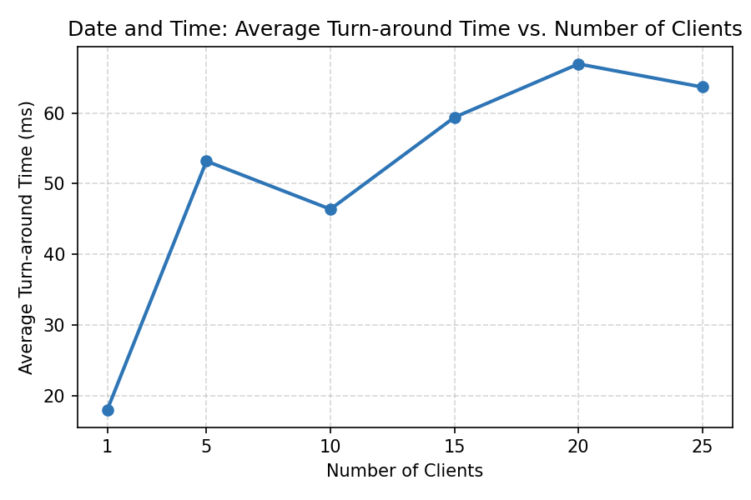
Average Turn-around Time (ms)
Number of Clients

Uptime (“uptime”)
Number of Clients | Total Turn-around Time (ms) | Average Turn-around Time (ms)
1 | 20 | 20.00
5 | 174 | 34.80
10 | 501 | 50.10
15 | 1004 | 66.93
20 | 1394 | 69.70
25 | 2231 | 89.24
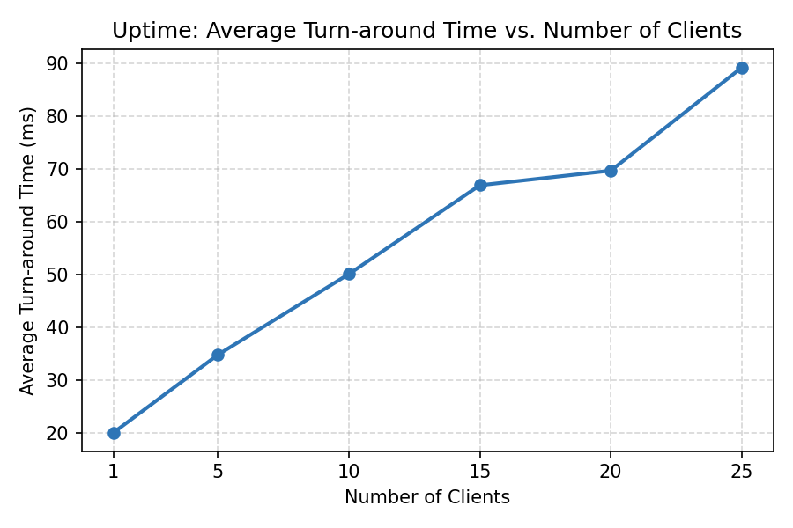

Memory Use (“free -h”)
Number of Clients | Total Turn-around Time (ms) | Average Turn-around Time (ms)
1 | 22 | 22.00
5 | 161 | 32.20
10 | 492 | 49.20
15 | 904 | 60.27
20 | 1419 | 70.95
25 | 1959 | 78.36
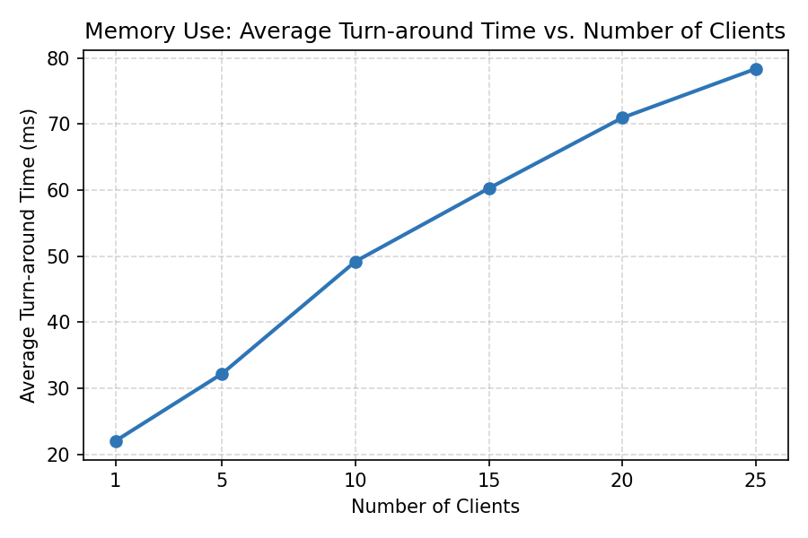

Netstat (“netstat -tuln”)
Number of Clients | Total Turn-around Time (ms) | Average Turn-around Time (ms)
1 | 21 | 21.00
5 | 173 | 34.60
10 | 492 | 49.20
15 | 972 | 64.80
20 | 1474 | 73.70
25 | 2420 | 96.80

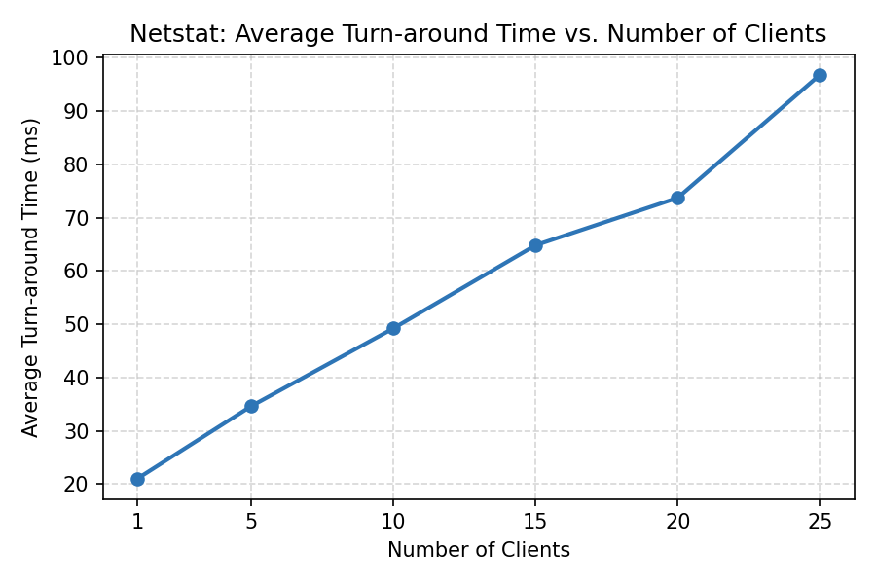

Current Users ("who")
Number of Clients | Total Turn-around Time (ms) | Average Turn-around Time (ms)
1 | 23 | 23.00
5 | 236 | 47.20
10 | 581 | 58.10
15 | 1104 | 73.60
20 | 1744 | 87.20
25 | 2784 | 111.36

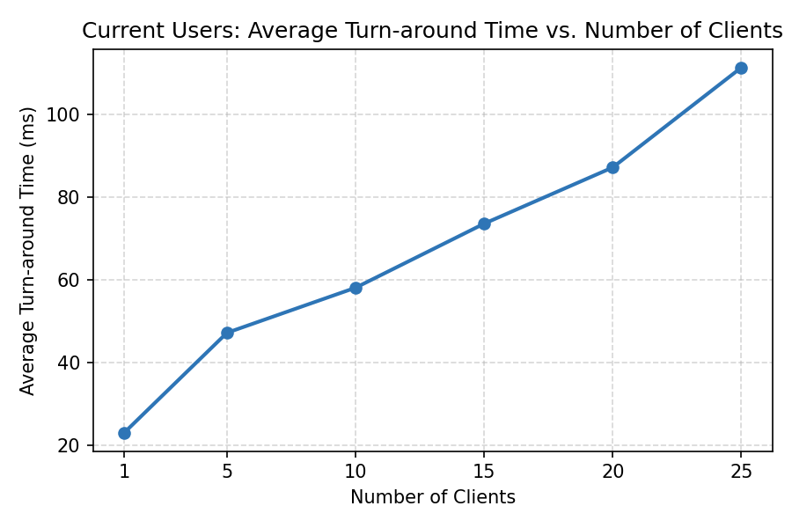

Running Processes ("ps aux")
Number of Clients | Total Turn-around Time (ms) | Average Turn-around Time (ms)
1 | 39 | 39.00
5 | 349 | 69.80
10 | 1002 | 100.20
15 | 1981 | 132.07
20 | 3295 | 164.75
25 | 4788 | 191.52

Running Processes: Average Turn-around Time vs Number of Clients
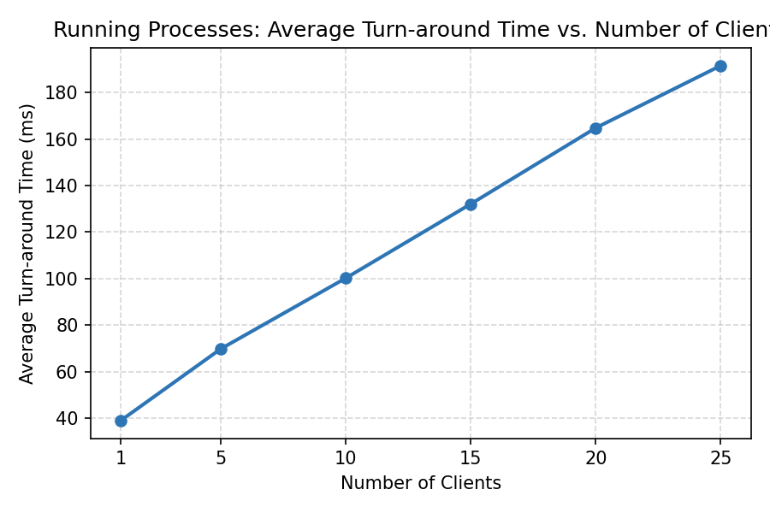

Combined Comparison Across Operations

The chart below overlays the average turn-around time curves for all six operations on a single set of axes. This makes it easier to compare how steeply each operation’s performance degrades as client load increases, and to see which operations are consistently more expensive than others, regardless of load.

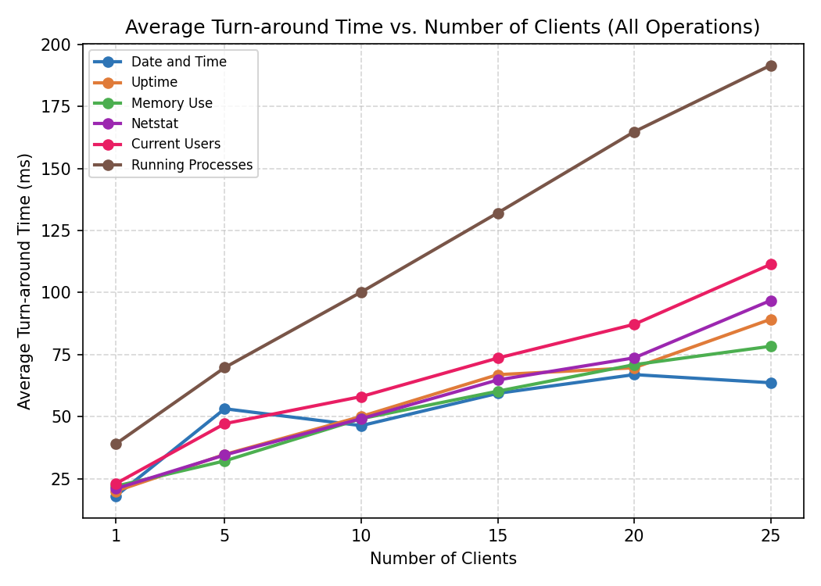

The chart below shows Total Turn-around Time across all operations. Since Total Turn-around Time is approximately the sum of N individual turn-around times, it grows with both the number of clients and the per-request cost of the operation, highlighting how dramatically more expensive operations such as Running Processes become at higher client counts.

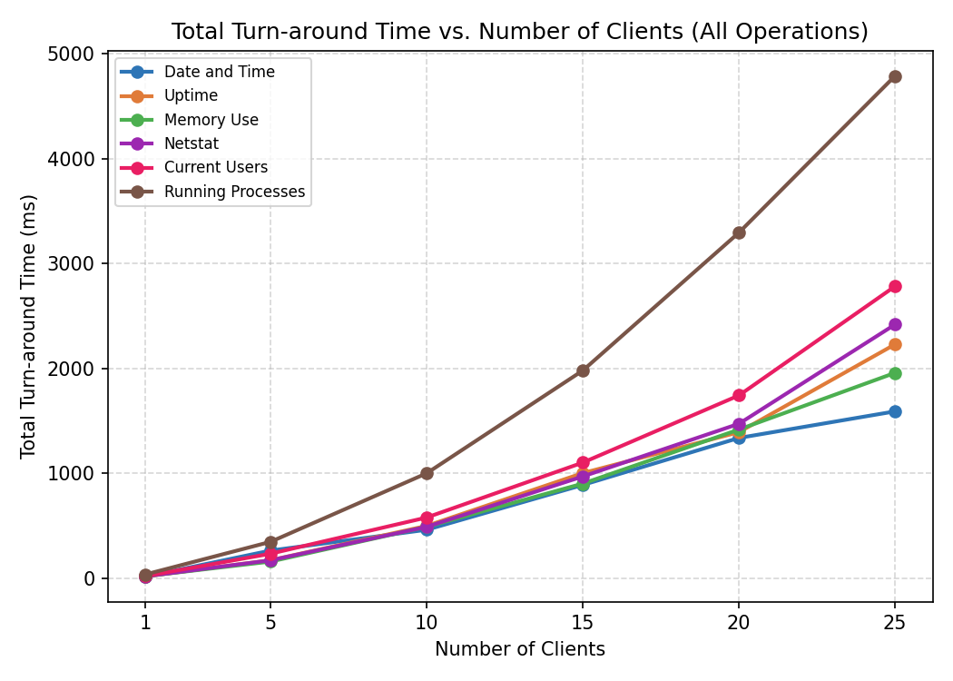

Data Analysis

What effect, if any, does increasing the number of clients have on the Turn-around Time for individual clients?
Across all six operations, increasing the number of clients clearly increases the turn-around time experienced by individual clients, particularly for clients that are served later in the queue. Because the server is iterative and handles only one connection at a time, every additional client that is launched simultaneously must wait behind all of the clients that were accepted before it. In the raw per-client data we collected for Date and Time and Netstat, this effect is visible directly: with only 5 clients, individual turn-around times ranged from roughly 19ms to 46ms, but with 25 clients, individual turn-around times for Date and Time ranged from about 19ms for the first client served all the way up to 103ms for the last client served. The earliest clients to be accepted experience a turn-around time close to the baseline single-client cost of the operation, while the last clients to be served experience a turn-around time that is roughly proportional to their position in the queue multiplied by the per-request service time. In other words, individual turn-around time becomes increasingly position-dependent as the client count grows: early clients are barely affected, while late clients are delayed by the cumulative processing time of every client ahead of them.

What effect, if any, does increasing the number of clients have on the Average Turn-around Time?
The Average Turn-around Time also increases as the number of clients increases, though less dramatically than the worst-case individual turn-around time, because the average smooths out the very fast early clients and the very slow late clients. For every operation we tested, the average turn-around time at 25 clients was substantially higher than at 1 client. For example, the average turn-around time for Date and Time grew from 18.00 ms with a single client to 63.38 ms with 25 clients – roughly a 3.5x increase. The effect is even more pronounced for the more expensive operations: Running Processes grew from 39.00 ms at 1 client to 191.52 ms at 25 clients, almost a 5x increase, and Current Users grew from 23.00 ms to 111.36 ms, roughly a 4.8x increase. While the growth is not perfectly linear in our data – there are small dips and bumps between some client counts, likely due to background load on the shared course servers and normal measurement variance – the overall trend across all six operations is unmistakably upward: more concurrent clients result in a higher average turn-around time.

What is the primary cause of the effect on individual client Turn-around Time and Average Turn-around Time?
The primary cause of both effects is the server’s iterative, single-threaded design. Because the server can only accept() and fully process one connection at a time, every client beyond the one currently being served must wait in the operating system’s connection backlog. From the perspective of any individual client, its measured turn-around time is not simply the cost of executing the request command (date, uptime, free -h, netstat -tuln, who, or ps aux) – it is that cost plus however long the server spends serving every client that was accepted ahead of it. As the number of simultaneously launched clients increases, the length of that queue increases linearly, and so does the worst-case wait time. Since the Average Turn-around Time is simply the mean of all the individual turn-around times, and the queue of waiting clients grows with N, the average necessarily increases with N as well – the server simply cannot perform more total work in less time just because more requests arrive at once. This also explains why operations with a higher baseline cost, such as Running Processes (which must enumerate and format information for every process on the system), show a much steeper increase than cheaper operations such as Date and Time: every additional client in the queue adds approximately that operation’s per-request service time to the wait of every client behind it, so a more expensive operation compounds the queuing delay faster as client count grows.

Conclusion

This project demonstrated, both through implementation and through empirical measurement, the fundamental limitation of an iterative server architecture: throughput does not scale with the number of concurrent clients, because the server can never do more than one unit of work at a time. Across all six operations we tested, both the individual client turn-around time increased as the number of simultaneously launched clients increased from 1 to 25. The effect was most severe for the more computationally expensive operations, such as Running Processes, where the average turn-around time nearly quintupled between 1 and 25 clients, and least severe for cheap operations like Date and Time, where the increase was still significant but less extreme.

From these results, we can conclude that an iterative server is best suited to environments where client requests are infrequent, lightweight, and unlikely to overlap in time. As soon as multiple clients are likely to arrive within a short window of each other, which is the normal case for any real network service with more than a handful of users, an iterative server becomes a serialization bottleneck, and every client pays a queuing delay proportional to the number of clients ahead of it. This strongly motivates the use of concurrent (multi-threaded, thread-pool-based, or asynchronous event-driven) server architectures for any service expected to handle multiple simultaneous users, since such architectures allow the server to begin processing a new client’s request without first finishing every prior client’s request, dramatically reducing the queuing component of turn-around time.

Lessons Learned
- Implementing the server-side protocol required careful thought about how to signal the end of a multi-line response. Commands like ps aux and netstat -tuln can produce many lines of output, so a simple readLine() on the client side is not enough to know when the response is complete – we needed an explicit end-of-message sentinel (“##END##”) that both sides agree on.
- Having a Java program execute Linux shell commands via ProcessBuilder was straightforward once we remembered to redirect the error stream into the standard output stream and to call waitFor() so the process fully completes before we read all of its output.
- Using a CountDownLatch and an AtomicLong made it easy to coordinate many concurrently running client threads and safely aggregate their individual timing results without introducing race conditions on the shared total.
- We observed some non-monotonic fluctuations in the data (for example, the average turn-around time for Date and Time at 10 clients was slightly lower than at 5 clients), which reminded us that measurements taken on a shared, multi-user course server are subject to background load and are not perfectly user course server are subject to background load and are not perfectly repeatable – running multiple trials and/or averaging over repeated runs would likely produce smoother trends.
- Overall, this project gave us a much more concrete understanding of why real-world servers are virtually ever built using a strictly iterative accept-process-respond loop, and why multi-threaded or event-driven server designs are the standard for production network services.

